Saketh Aripirala

Effects of Bass Guitar Pickups on Pitch Detection and Pitch Shifting

Metropolia University of Applied Sciences

Bachelor of Engineering

Electronics

Bachelor’s Thesis

1 March 2021

Abstract

Author: Saketh Aripirala

Title: Effects of Bass Pickups on Pitch Detection and Shifting

Number of Pages: xx pages + x appendices

Date: 1 March 2021

Degree: Bachelor of Engineering

Degree Program: Electronics

Professional Major: Bachelor’s Thesis

Supervisors: Heikki Valmu, Principal Lecturer

Juha Kivekäs, Technical Supervisor

Keywords: Guitar Pickups, Digital Signal Processing, Python, Bass Guitars

___________________________________________________________

Contents

List of Abbreviations

1 Introduction 1

2 Fundamental Theories and Concepts 2

2.1 Digital Signal Processing 2

2.2 YIN Algorithm 7

2.2.1 Autocorrelation Function 8

2.2.2 Difference Function 10

2.2.3 Cumulative Mean Normalized Difference Function 12

2.3 Octaver Algorithm and Model 13

2.3.1 Analog Octaver 14

2.3.2 Octave Error 18

2.3.3 Phase Error 19

2.4 Pickup Fundamentals 20

2.4.1 Magnetic Pickups 21

2.4.2 Piezo-electric Pickups 26

3 Testing Methods 28

3.1 Debugging Pre-Amplifier and Bass Modifications 28

3.2 Test Data and Considerations 37

3.3 Python Testing Script and Sonic Visualizer 38

4 Results 44

4.1 Data Correlation 44

4.2 Error Cases and Types 44

4.3 Pickup Types and Effects 44

5 Discussion 44

6 Conclusion 44

References 45

Appendices

Appendix 1: Datasheets

Appendix 2: Source Code

List of Abbreviations

DSP: Digital Signal Processing

FFT: Fast Fourier Transform

DFT: Discrete Fourier Transform

F0: Fundamental Frequency

ACF: Autocorrelation Function

CMNDF: Cumulative Mean Normalized Difference Function

JFET: Junction Field Effect Transistor

GPIO: General Purpose Input Output

Op Amp: Operational Amplifier

IC: Integrated Circuit

THD+N: Total Harmonic Distortion and Noise

PCB: Printed Circuit Board

SMD: Surface Mount Device

DC: Direct Current

AC: Alternating Current

PYSPTK: Python Signal Processing Tool Kit

# Introduction

In the world of digital audio processing, pitch manipulation effects and sound synthesis are commonly researched subjects and are widely used by musicians to alter and produce new sounds. The origins of sound synthesizers traces back to the early 20th century, where analog oscillators are utilized to produce pure tone sounds such as sine, square, and sawtooth waves. In more modern applications, synthesis uses digital signal processing and hybrid systems to produce more complex musical tones. Similarly, pitch manipulation is a very popularly used tool to modify the perceived pitch of an instrument or speech. Most common styles of perceived pitch manipulation are often used to shift the signal to different musical intervals or alter the formants. An octaver is widely used on instruments to shift the signal down an interval of an octave, essentially halving the frequency of the signal. This results in more subharmonic bass frequencies.

With emerging audio technologies, the signal of a stringed instrument can be used to synthesize pure or complex tones by tracking the pitch of the note played. Although it may seem trivial to track the pitch or fundamental frequency of an instrument; in reality, there are complexities stemming from the timbre (tonal quality of a sound [1]) and the nature of the instrument that cause the tracking errors or inconsistencies. Comparable issues occur when the pitch is shifted and worsened with certain cases where an error cause perceivable differences.

By understanding the fundamentals of guitar pickup technology, a much wider comprehension of the role pickups play in the harmonic contents of the signal can be achieved. Moreover, methods to mitigate errors in these algorithms can also be investigated.

To test the role of pickup types in these errors and the overall functionality of the algorithms, a test bass guitar containing two specific types of pickups was utilized: a generic humbucker pickup in a split-coil configuration and an Ernie Ball piezo bridge pickup. To test these pickups in individual and mix configurations, a debugging pre-amplifier was designed using Altium Designer, an ECAD software. The primary test points include various heights, positions, and configurations of the pickups. Using python, a programming language widely used for data analytics, correlation functions are implemented to study the changes in the fundamental frequency tracking stability, errors, and phase changes. Lastly, the analysis of the harmonic contents in the signal and the testing method is validated using Sonic Visualizer.

The findings of the research aid Darkglass Electronics, a Finnish bass guitar accessory manufacturer, in pursuing technology and methods to implement bass guitar effects embedded into an instrument. The algorithms used to acquire the test data are effects made in-house by Darkglass Electronics, which include a faithful modelling of an analog octaver, a digital hybrid octaver, and a bass guitar synthesizer.

# Fundamental Theories and Concepts

To understand the errors conditions and research goals, it is quite essential to have a solid comprehension of the fundamentals of the implementation of the algorithms, guitar pickup technology, digital signal processing, and spectral analysis. The following section covers the necessary prerequisites.

## Digital Signal Processing

Digital signal processing is a commonly used technique to analyze and alter real world signals such as sounds, measurements, and data. Analog signals are discretized digitally using Analog-to-Digital converts and using fundamental mathematical functions, the data is manipulated [2.] To discretize analog signals, the signal is sampled recurring instances. The rate at which these instances are captured is known as the sampling frequency (*Fs*), measured in Hertz[3*.*] According to the Nyquist-Shannon sampling theorem, an analog signal can be accurately reconstructed only if the sampling frequency is more than twice the maximum frequency of the sample [4]. Failing to satisfy the Nyquist-Shannon theorem leads to an effect called signal aliasing. Equation (1) represents the mathematical form of the Nyquist-Shannon sampling theorem:

|  |  |
| --- | --- |
| $$F_{s}≥f_{max}$$ | (1) |

An essential concept in Digital Signal Processing is windowing and hop size. Windowing divides a signal into smaller intervals of signal for which the processing is performed. Typically, windows are overlapped after each other; the number of samples in non-overlapping regions of the window is called the hop size [5.] Figure 1 depicts windowing and hop size for an audio sample.  
  


Figure 1. Windowing and Hop size. Q denotes the hop size and K represents the window length [6].

In spectral analysis, the Fourier Transform of a signal is performed to calculate the magnitude of each frequency component present in a signal. The Fourier Transform is translated into DSP via the discretized and sample based Discrete Fourier Transform (DFT). The mathematical implementation of the Fourier Transform and DFT is shown in Equation (2) and (3):

Let $f\left(t\right)$ be a function. Then the Fourier Transform of the function is given as follows:

|  |  |
| --- | --- |
| $$F\left(k\right)=\int_{-∞}^{∞}{f\left(t\right)e^{-2πjkt}dt}$$ | (2) |

Where $j$ is the complex imaginary unit and $k$ is the frequency.

Then the DFT for $N$ number of samples is given by:

|  |  |
| --- | --- |
| $$F\left(k\right)= \sum_{k=0}^{N-1}{f\left(k\right)e^{-2πjk/N}}$$ | (3) |

Each value of $k$ denotes a frequency bin. The magnitude and phase of the frequency bin is calculated by using Equations (4) and (5):

Let $a+jb$ be a complex number where $j$ is the imaginary unit.

|  |  |
| --- | --- |
| $$Magnitude=\sqrt{a^{2}+b^{2}}$$ | (4) |
| $$Angle \left(θ\right)=\tan^{-1}{(\frac{b}{a})}$$ | (5) |

The Fast Fourier Transform (FFT) algorithm improves the implementation of the DFT. It requires fewer computational steps to perform the calculations.

The spectral information calculated using DFT can be represented by graphing the magnitude for each frequency bin or a spectrogram. The graphing method provides the harmonic contents of the signal as a function of its magnitude, whereas a spectrogram provides the magnitude of the harmonic contents, or frequency bins, as a function of time. Figure 2 and Figure 3 contain the graphing and spectrogram representations.



Figure 2. Graphing Frequency as a Function of Magnitude [7].



Figure 3. Spectrogram [7].

The lowest frequency component present in the signal is known as the fundamental frequency. In a periodic signal, multiples of the fundamental frequency are known as the harmonics or overtones [8.] The relationship between the fundamental frequency and subsequent harmonics is shown by Equation (6).

|  |  |
| --- | --- |
| $$f_{1}={2f}_{0}$$ $f_{n+1}=2f_{n}$ | (6) |

Where $f_{1}$ is the 1st overtone (or 2nd harmonic) and $f_{n}$ is the nth harmonic. The timbre of the sound is unique for different sounds due to the varying magnitudes of the harmonics. Figure 4 describes the relationship between the fundamental frequency and the subsequent harmonics. The period of the wave doubles for each harmonic i.e., frequency is twice. In music, it is generally accepted that the perceived pitch is the fundamental frequency of the signal.



Figure 4. Relationship between Fundamental Frequency and Subsequent Harmonics [9].

During spectral or harmonic analysis, it is quite valuable to apply the windowing when calculating the DFT of data to optimize accuracy or performance. The windows are often truncated by applying various window functions such that the samples taper to zero at the start and the end of the window. It is beneficial to apply windowing functions to the window when performing spectral analysis to avoid the effect of spectral leakage. The phenomenon of spectral leakage causes the magnitude information of a frequency bin to affect other bins [10]. This is often caused due to the overlapping windows causing discontinuities in the signal, as shown in Figure 5.



Figure 5. Discontinuities Produced when No Window Function is Applied [10].

## YIN Algorithm

As initially established, estimating the fundamental frequency is a non-trivial subject due to the timbre of a signal. The harmonic contents play a large role in the transient changes and time domain contents of the signal. Most fundamental frequency estimations fail to account for these changes. The YIN algorithm by Alain de Cheveigné and Hideki Kawhara [13] is a robust method that improves existing implementations for fundamental frequency estimations. The three stages of the YIN algorithm are as follows:

1. Autocorrelation
2. Difference Function
3. Cumulative Mean Normalized Difference Function

The YIN algorithm is used in Darkglass’ in-house bass guitar synthesizer, which produces a synthesized bass signal. Moreover, it is also implemented as a plugin in Sonic Visualizer to help validate the accuracy of the pitch correlation tool created for the research.

### Autocorrelation Function

The Autocorrelation Function (ACF) is commonly used in statistics and signal processing for measuring the correlation between the signal and its time delayed variant [11]. The ACF of a periodic signal always returns a perfect correlation and the smallest time delay denotes the period of the signal [12]. The inverse of the time delay is an estimate of the frequency of the signal. Mathematical representation of the ACF function is presented in Equation (7):

Let $s(t)$ be a periodic signal, then its ACF $R\left(τ\right)$ with delay $τ$ is:

|  |  |
| --- | --- |
| $$R\left(τ\right)=\frac{1}{(t_{max}-t_{min})}\int_{t_{min}}^{t_{max}}{s\left(t\right)s(t+}τ)dt$$ | (7) |

The equation can be applied for a discrete signal with a window width of $W$ and time delay $τ$, hence Equation (7) can be modified; as shown in below in Equation (8):

|  |  |
| --- | --- |
| $$r\left(τ\right)=\sum_{j=t+1}^{t+W-τ}{x_{j}x_{j+τ}}$$ | (8) |

The ACF holds for estimating the fundamental frequency of pure tones; but for varying periods in a signal, the ACF fails and produces errors. In Figure 6 the ACF values over a lag range for a sample signal is illustrated.



Figure 6. (a) Sample Signal. (b) Autocorrelation of the Sample Signal [13].

Listing 1 contains the python script to find the frequency of a sine wave using the ACF. The script utilizes a window width of 200 samples and generates a 5-second-long sine wave with a sampling frequency of 500.

def f(x):

f_0 = 1

return np.sin(x * np.pi * 2 * f_0)

#Generates a sine wave with frequency of 1 Hz

def ACF(f, W, t, lag):

return np.sum(f[t : t + W] * f[lag + t : lag + t + W])

def returnACF(f, W, t, fs, bounds):

ACFv = [ACF(f, W, t, i) for i in range(*bounds)]

sample = np.argmax(ACFv) + bounds[0]

return fs / sample

Listing 1. Python script to create a sine wave and find its frequency using the ACF.

As expected, the ACF holds and returns a result of 0.9823 Hz, which can be rounded up to 1 Hz. Applying an exponentially decaying envelope to the sine signal as shown in Listing 2 proves that the ACF does not hold for decaying signals with varying amplitude or fluctuating periods. Using the same parameters, the ACF returns a frequency estimate of 25 Hz.

def f(x):

f_0 = 1

envelope = lambda x: np.exp(-x)

return np.sin(x * np.pi * 2 * f_0) * envelope(x)

Listing 2. Modified Sine Wave with a Decaying Envelope.

The sine wave with the envelope is shown in Figure 7 below.



Figure 7. Sine Wave with an Exponentially Decaying Envelope.

### Difference Function

For a shift invariant system, it is true that when a discrete signal $x_{t}$ with period $T$ is shifted by a time constant the output is equally shifted. Using this property, the following Equation (9) also holds true [13.]

|  |  |
| --- | --- |
| $$x_{t}-x_{t+T}=0$$ | (9) |

Similarly, by squaring the sums of Equation, the smallest time shift where the difference is zero gives the period of the signal. Equation (10) below describes the difference function for a discrete signal $x_{t}$ using a sampling window of $W$ and time shift $τ$ [13.]

|  |  |
| --- | --- |
| $$d_{t}\left(τ\right)= \sum_{j=1}^{W}{\left(x_{j}-x_{j+τ}\right)}$$ | (10) |

The difference function does not improve over the ACF in terms of estimating the fundamental frequency, but rather reduces the overall errors produced by the ACF. An elucidation for this is that the ACF is much more sensitive to amplitude. Moreover, the difference function can be described in terms of the ACF as shown by Equation (11) [13.]

|  |  |
| --- | --- |
| $$d_{t}\left(τ\right)= r_{t}\left(0\right)+r_{t+τ}\left(0\right)-2r_{t}(τ)$$ | (11) |

The same is implemented in a python function as shown in Listing 3.

def DF(f, W, t, lag):

return ACF(f, W, t, 0) + ACF(f, W, t + lag, 0) - (2 * ACF(f, W, t, lag))

Listing 3. The Difference Function Implemented in terms of the ACF using Python.

Due to the difference function being an intermediate step of the YIN algorithm, the values of the difference function being used for estimating the fundamental frequency bears no value despite producing lower errors than the ACF. Hence, it was not tested using python.

### Cumulative Mean Normalized Difference Function

The cumulative mean normalized difference function (CMNDF) is the final stage of the YIN algorithm. The presence of the 2nd harmonic causes the difference function to produce zero lag regions, hence inducing errors [13]. The CMNDF avoids these zero lag regions and improves upon the difference function. Equation (12) below shows the CMNDF:

|  |  |
| --- | --- |
| $$d^{'}\left(τ\right)=\left\{\begin{aligned}1, if τ=0 \\ \frac{d_{t}\left(τ\right)}{\left[(\frac{1}{τ})\sum_{j=1}^{τ}{d_{t}(j)}\right]}, for all other τ\end{aligned}\right.$$ | (12) |

The function accomplishes lower errors by dividing the preceding difference function value over its average of shorter lag values. To further reduce errors, using an absolute minimum threshold for the lag values is useful since if no lag values are found, the function can default to the absolute threshold [13.]

Using the parameters from Listing 1 and the decaying sine wave, the CMNDF implementation and F0 detection implementation in python is presented in Listing 4 below.

def CMNDF(f, W, t, lag):

if lag == 0:

return 1

return DF(f, W, t, lag) / np.sum([DF(f, W, t, j+1) for j in range(lag)]) * lag

def detect_pitch(f, W, t, fs, bounds, thresh = 0.1):

CMNDF_vals = [CMNDF(f, W, t, i) for i in range(*bounds)]

sample = None

for i, val in enumerate(CMNDF_vals):

if val < thresh:

sample = i + bounds[0]

break

if sample is None:

sample = np.argmin(CMNDF_vals) + bounds[0]

return fs / sample

Listing 4. CMNDF and Fundamental Frequency Estimation.

Applying the detect pitch function on the decaying sine wave returns an F0 estimation of 1.002 Hz, which is 0.2% above the exact F0 of 1 Hz. Furthermore, the recommended threshold is 0.1 [13]; increasing the minimum threshold to 1 returns an estimate of 1.36 Hz, consequently increasing the error. Introducing bounds to the search range of the lag value is also beneficial to the processing time and improves the accuracy of the algorithm [13]. The knowledge pertaining to the source of the sound is also valuable. For example, in the Darkglass bass synthesizer, the frequency range of the bass guitar helps optimize the algorithm.

## Octaver Algorithm and Model

The octaver is a signal processing effect that shifts a signal down a musical interval of an octave, which leads to the signal’s frequency to be halved. The measure for the shift in musical intervals from a reference frequency is defined as a semitone [14]. For two frequencies $f_{1}$ and $f_{2}$, the interval distance is calculated by using Equation (13):

|  |  |
| --- | --- |
| $$Semitones=12*log⁡(\frac{f_{2}}{f_{1}})$$ | (13) |

An octave is 12 semitones apart from a reference pitch. Octavers are commonly used with guitars and basses to produce sub-bass frequencies. Furthermore, the octave down signal is also typically mixed with other types of effects such as distortion. Octavers are popularly used in the pedal format using analog or hybrid processing, but purely digital versions are also available and largely utilized. The digital formats provide the advantage of polyphonic processing; allowing a signal containing multiple frequency intervals to be shifted. Frequency domain-based processing is a common pre-requisite for the polyphonic processing. Whereas, for analog octavers, the processing is monophonic, where only one frequency is processed at a time. Analog octavers are often time-domain processing.

### Analog Octaver

The working principle of an octaver is to generate a square wave at half the frequency of a periodic signal. The generated square wave is used to manipulate the incoming signal. A common method to manipulate the signal is by muting. To achieve the cyclic manipulation, the peak of the signal needs to be detected and every other peak of the signal is considered as a candidate for the mute control circuit. As previously established, audio signals do not have perfect periodicity and can have varying amplitudes. This effect leads to muting in varied periods and can cause discrepancies in the resulting audio signal because of inharmonic and decay of different partials. Due to the confidentiality and the legality of sharing schematics of popular octavers, the block diagram of the block diagram of an analog octaver is only presented, as shown in Figure 8 below.

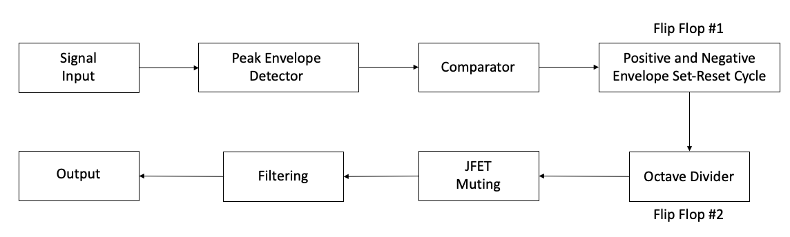

Figure 8. Analog Octaver Signal Block Diagram.

The most important section of the octaver is the generation of perfectly periodic square wave signals that alternate every second cycle of the signal. To achieve this, an analog peak detector is implemented using operational amplifiers (Op Amps). The signal is first clipped such that it converts the signal to an almost-square wave, this is achieved using diodes and a gain stage to amplify the signal, like distortion circuits. Second, the positive and negative half segments of the signal are individually peak detected. It outputs an exponentially decaying envelope of the peak. Third, the output of the signal is compared with a reference voltage to detect new peaks using op amp comparators, which produce a signal between HIGH and LOW every time the signal crosses or falls below the threshold. The comparators essentially produce a pulse every time a new positive or negative peak is detected. The output of each stage is shown below for a 100 Hz sine wave signal.



Figure 9. Stages of Muting Signal Generation.

Finally, the peak detected pulses are fed to two D-Flip Flop circuits. The set and reset signals are produced in a manner that the circuit sets for every new positive peak and reset for a negative peak in the first flip flop. With the second flip flop, the period is doubled by enabling set every rising edge of the previous flip flop stage. The output of the first and second flip flop stages are presented in Figure 10 below.

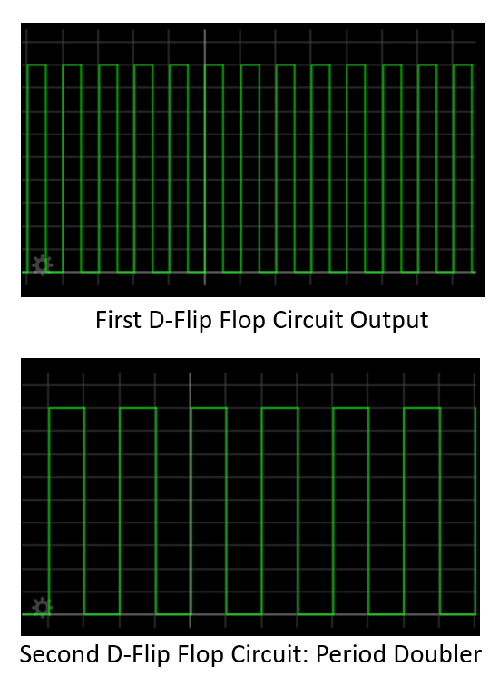

Figure 10. Flip Flop Circuit Output.

The output of the period doubling flip flop circuit is used as a JFET muting circuit control signal; the JFET conducts to ground when the signal goes LOW and vice versa. Abrupt muting in the signal causes high frequency contents and harmonics which degrade the audio quality. To remove these unnecessary frequencies, a low pass filter is implemented. The final octave signal is achieved at this stage of the processing. It is quite common to add a signal mixer between the processed sub frequencies and the original clean signal for more control over the sound of the octaver. The final output signal of the octaver is shown Figure 11 below.



Figure 11. Octaver Output.

The analog octaver can be modelled using digital signal processing by emulating the analog component logic. Furthermore, the octaver’s errors can be reduced by implementing the ACF, or a hybrid of the analog and ACF. Although the ACF reduces overall occurrences of errors, it is still prone to producing octave errors in special cases. Lastly, methods other than the muting can be implemented to produce the octaver’s effect, such as a flipping the phase of the signal. The output of an analog octaver model implemented using Darkglass’ DSP methods in python is presented in Figure 12 below. The test signal is a 100 Hz sine wave.

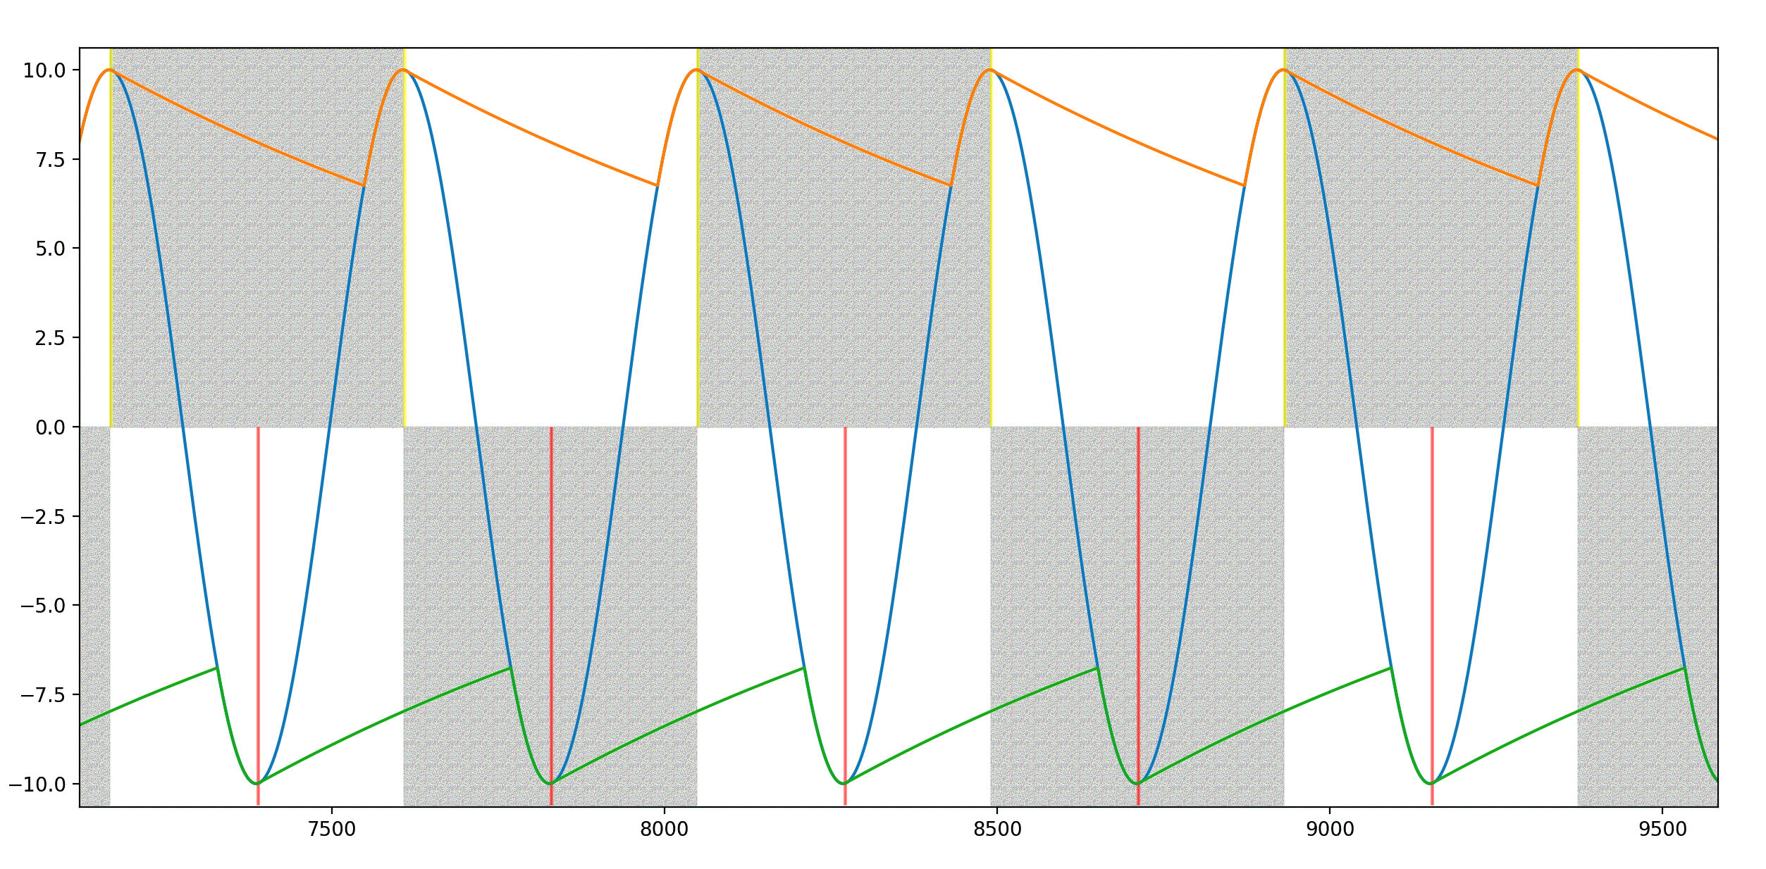

Figure 12. Darkglass’ Digital Model of an Analog Octaver. Orange and Green represent the envelope. Yellow and Red are the new Peak Detections.

Typically, the analog octaver implementation may produce errors in certain cases. The two significant errors are the following:

1. Octave Error
2. Phase Error

### Octave Error

The octave error occurs during sustained audio signals (inverse of rate of decay [15]). During the decay of the audio signal, the fundamental signal does not show dominant presence throughout the duration of the decay. Other harmonics typically show more presence during decay of the envelope of the signal. In a spectral analysis point of view, the fundamental frequency is still dominant. Due to this effect, the peak detector accounts for the new harmonics hence leading to the frequency of the flip flop circuit doubling. In Figure 13, the first two cycles of the analog flip flop circuit (vertical red marking) produce perfect muting at alternating cycles of the signal. Whereas the advancing cycles have twice the period due to the envelope containing two dominant peaks. The SUB_ANALOG square wave contains the set-reset cycle error.



Figure 13. Octave Error. Signal Before the Red Line Marks the First Two Cycles of the square wave (SUB_ANALOG) with the Correct Period.

The octave error causes shifts in the signal’s frequency. Furthermore, muting at varied cycles of the signal causes the output to shift into other frequencies; producing a slight detune effect.

### Phase Error

Phase error produces subtle to very audible effects in the signal. Furthermore, it also affects the mixing of signals. The error occurs when the flip flop circuit polarity flips state. This causes the muting to take place 180 degrees out of phase. When two signals are mixed, opposing phases cause destructive interference and reduce the overall loudness of the signal [16]. Figure 14 marks the polarity change (black line) in the square wave, consequently causing a phase error.

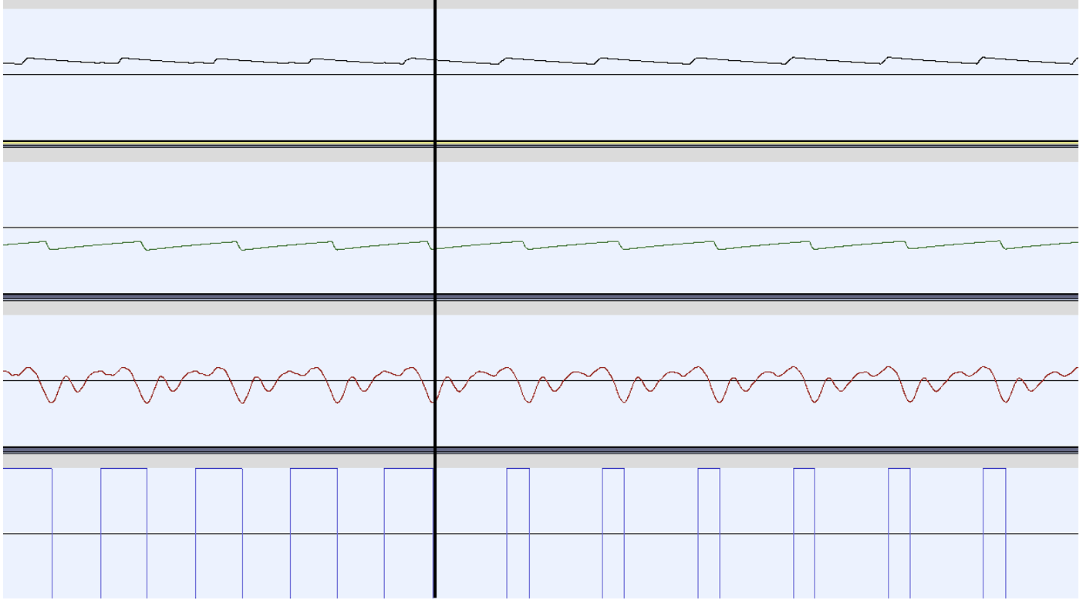Figure 14. Phase Error. The Square Wave Inverts Polarity while Maintaining the Same Period after the Black Line.

## Pickup Fundamentals

In acoustic instruments, the sound of the strings is amplified through the sound hole [17.]. Development of solid bodies for acoustic instruments (such as guitars and basses) simultaneously lead to the electrification of them. The sound of the instrument is captured through a transducer called pickup [18]. Pickups are essential for a guitar and bass as they mainly define the overall sonic qualities of the instrument and facilitate the usage of effects to amplify and alter the sound of the instrument.

The placement of the pickup plays a large role in the overall dynamic range and frequency response of the signal. Moreover, the timbre also greatly varies [19]. Common placements of the pickup in a guitar are the neck, middle, and bridge positions. The output voltage increases closer to the neck of the guitar while the presence of higher order harmonics decreases [19]. Pickups are classified into two types:

1. Magnetic Pickups
2. Piezo-electric Pickups

The primary difference between the two types of pickup is based on their construct and output.

### Magnetic Pickups

Magnetic pickups are constructed by winding wire to form a coil around a permanent magnet [20]. The working principle of a magnetic pickup is based on the Faraday’s Law of Induction, which states that changes in the magnetic field induces current into the coil [21]. Figure 15 shows the inner construction of the pickup.



Figure 15. Construction of a Magnetic Coil Pickups [20].

Electrically, an ideal magnetic pickup can be simplified to an LCR circuit. Furthermore, the pickup can also be treated as an AC voltage source to the LCR circuit [22]. In Figure 16, the equivalent circuit can be observed.



Figure 16. Electrical Equivalent Circuit of a Pickup [22].

The ideal pickup circuit behaves as a resonance circuit; therefore, a single frequency contains the highest amplitude. The resistive and capacitive elements form a low-pass filter, leading to frequencies above the cut-off frequency having lower amplitudes [22]. The frequency response and resonance of an ideal pickup circuit is presented in Figure 17.



Figure 17. Frequency Response and Resonance of a Magnetic Pickup [22].

Due to external factors such as capacitance in cables, control potentiometers, and eddy currents in conductive parts, the overall frequency response and the resonance frequency can change [22]. Furthermore, the pickup can only detect the changes through the magnetic field, hence it is independent of the displacement of the string and much more sensitive to the velocity of the strings. Strings also tend to produce lesser displacement at higher frequencies. The two effects essentially cancel each other out [19.]

In addition, the displacement of a string along a particular axis and the distance between the string and the pickup $\left(d_{0}\right)$ produces varied harmonic contents in the signal. The axis definitions and distances are shown in Figure 18. The output signal produces non-linear characteristics when the distance $(d_{0})$ between the string and the pickup is small, whereas the output has a much more linear nature when placed farther away. The displacement along the Z-axis contains most of the fundamental frequency and movement along the Y-axis produces higher order harmonics. Moreover, the distortion also worsens for Y-axis motion [23.]



Figure 18. Axis Definitions [23].

The signal output of the string excitation along the Z-axis and Y-axis are presented in Figure 19.



Figure 19. Left: Output for Displacement Along Z-axis. Right: Output for Displacement along Y-Axis [23].

Magnetic pickups have two common configurations:

1. Single Coil
2. Humbucker

The single coil configuration consists of an array of permanent magnets with a single coil. Single coils are susceptible to external magnetic fields, therefore, produce a hum-like sound and buzz [24.] Additionally, single coil pickups contain a considerable amount of high frequency contents, commonly characterized as “brighter” sounding [25.] Figure 20 illustrates a single coil pickup.



Figure 20. Single Coil Pickup [26].

Humbuckers inherently overcome the susceptibility of external magnetic fields. Humbucking pickups are constructed using two coils around magnetic pole pieces with alternating polarity. The output of the two coils are 180 degrees out of phase with each other, hence eliminate noise when mixed [24.] The overall output of the humbucker configuration is much greater than a single coil. Figure 21 depicts the humbucking effect.



Figure 21. Humbucking Effect [20].

The internal construction of a humbucker is equivalent to two single coil pickups connected in series. Figure 22 shows the humbucker pickup construction.



Figure 22. Humbucker Pickup [27].

Humbucker coils are also connected in several ways. Namely, the split-coil configuration and series-parallel configuration. The split-coil configuration effectively shorts one side of the humbucker coils to ground, rendering it to operate like a single coil pickup. This produces high frequency contents, but it also introduces the drawbacks of excess noise and lowers the overall output. The series-parallel configuration maintains the humbucking nature of the pickup, while preserving the high frequency contents [24.] The two configurations for connecting a humbucker pickup are presented in Figure 23.



Figure 23. Humbucker Configurations. (a) Split Coil Configuration. (b) Series-Parallel Configuration [24].

### Piezo-electric Pickups

Piezo-electric pickups operate based on the principle of piezo-electricity. The effect is produced when a crystal is subject to mechanical stress (or pressure), thus causing a voltage drop across. Crystals are molecular structures that are arranged in an orderly manner. The piezo-electric effect is widely used in medical ultrasound equipment, microphones, and time-keeping devices [28].

Similarly, in pickups, the crystal is placed in the bridge of the guitar. The pressure of the string motion across the bridge produces a current at the frequency of the string’s vibration. Basic internal structure of the piezo-electric pickup is illustrated in Figure 24.



Figure 24. Basic Piezo-electric Pickup Structure [29].

The voltage output across the crystal is typically very low for direct usage, therefore require a pre-amplifier. Furthermore, the output of the piezo-electric pickup is non-linear. The output voltage does not scale very well with the dynamics of the string, hence causing distortion or abundance of quietness to occur in the audio. To prevent this, the signal is compressed in the pre-amp to maintain uniform signal levels throughout [30.] In addition, piezo-electric pickups have high output impedance and capacitance. Pre-amplifiers are commonly designed using discrete JFET amplifier circuits or JFET based Op Amp ICs (Integrated Circuits), since JFETs offer high input impedance and low output impedance [31.] This prevents excessive loading in other stages. Component selection is quite imperative as pre-amplifiers need to maintain low Total Harmonic Distortion and Noise (THD+N). A basic piezo-electric pre-amplifier is presented in Figure 25.



Figure 25. Basic Piezo-electric Pre-amplifier [30].

# Testing Methods

The ideal behavior of the pickup is to produce the least number of errors with the octaver models and the YIN algorithm-based bass guitar synthesizer. It is necessary to understand the harmonic contents of the signals produced by the two pickups and compare the types of errors produced. The subsequent section covers the testing methods for the pickups and testing requirements.

## Debugging Pre-Amplifier and Bass Modifications

To test the piezo and humbucker pickups, a generic bass guitar was modified to contain both pickups. Data for testing both the pickups was routed through a debugging Pre-Amplifier Printed Circuit Board (PCB); designed using Altium Designer ECAD software. The objectives for the debugging pre-amplifier were to provide an ease of accessing audio signals from both pickups and ensuring low noise and distortion. The bass guitar is pictured in Figure 26.



Figure 26. Bass Guitar.

The piezo pickup under test was an Ernie Ball Piezo Bridge Pickup included with a Fishman pre-amplifier. Furthermore, the humbuckers were connected in a split-coil configuration with volume controls for each coil. The debugging PCB block diagram is shown in Figure 27.



Figure 27. Debugging Pre-Amplifier Block Diagram.

Due to the piezo pickup’s location being on the bridge, the original bridge on the bass was replaced. The string tension and the overall scale length of the guitar had to be considered during the replacement, since the consequences of inadequate string tension would lead to difficulty in maintain intonation and tuning. To achieve this, the original placement and string positions on the saddles were marked on the bass. Furthermore, the original cavity for the electronics on the bass guitar was deemed to be insufficient for the addition of a PCB and the Fishman pre-amp. Therefore, the cavity was expanded. Similarly, an additional cavity was made to route the leads from the piezo bridge pickup. Figure 28 contains the bridge position markings and the cavities.



Figure 28. Left: Bridge Position Markings. Right: Expanded Cavities.

Subsequently, the electronics for the debugging PCB were designed and simulated. The PCB was designed to ensure it was modular, consequently making debugging easier if issues were to occur due to design flaws. To accomplish modularity, Surface Mount Device (SMD) pads were utilized extensively.

Taking power supply noise into consideration was vital to the overall design of the PCB. Most generic power DC (Direct Current) supplies often contain a rectifier, or a regulator based designed. While they both have benefits, the most common susceptibility is RF and ground noise. Although RF frequencies are imperceivable by human ears, ground noise produces a buzz like effect at 50 Hz. For audio signals, this causes considerable disturbances in a signal. The effects of bad power supply sources can be mitigated by using proper precautions such as shielding, filtering, and grounding [32]. Figure 29 presents the power supply design schematics.



Figure 29. Power Supply Design Schematics.

The input DC voltage was connected to a center negative DC barrel power jack using wire leads; consequently, connecting the tip to ground and the sleeve to the positive supply voltage. D1 in the schematics is a Schottky diode to prevent reverse polarity connections, thus preventing accidental usage of negative supply voltage. Furthermore, ferrite bead L1 was implemented to filter power supply voltage. The specifications of the ferrite bead (Appendix 1) were chosen such that it offers low DC resistance, current rating, and a high resonant frequency. Then, the R4 and C2 form a low pass filter. R4 also acts as an overcurrent protection when excess current is drawn by the ICs, and C2 is a bypass capacitor that stores current and provides it when demanded. The cut-off frequency for the low pass filter is calculated using Equation (14) and subsequently, the cut-off frequency is calculated. The frequency response of the circuit is presented in Figure 30.

|  |  |
| --- | --- |
| $$F_{c}=\frac{1}{2πRC}$$ | (14) |
| $$F_{c}=\frac{1}{2π*10*220*{10}^{-6}}→F_{c}=72.3 Hz$$ |  |
|  |  |



Figure 30. Power Supply RC Low Pass Filter Response.

Lastly, Zener diode D2 prevents shorts circuits to ground. Since active components require a bias point, the bias voltage (VREF) is generated by the voltage divider formed by R5 and R6; and C3 is a bypass capacitor. The output of the voltage divider is calculated using Equation (15).

|  |  |
| --- | --- |
| $$V_{out}=V(\frac{R_{2}}{R_{1}+R_{2}})$$ | (15) |
| $$V_{out}=9*\left(\frac{{10*10}^{3}}{10*{10}^{3}+10*{10}^{3}}\right)=9*\left(\frac{1}{2}\right)→V_{out}=4.5V$$ |  |

Following the power supply design, the humbucker input stage was designed. The primary consideration was high impedance of the pickup and the volume potentiometers for the individual coils. An ideal op amp in theory can handle the high input impedance without excessive loading, but this does not imply the same in practice. The utilization of Bipolar Junction Transistors based op amps in high impedance applications comes with a noise penalty and possibility of loading, which degrades the quality of the signal or drives the op amp to non-linearity. Furthermore, JFET based op amps are typically known for their high input impedance and low output impedance; therefore, a much more suitable option [24.] The TL072C op amp is a cost effective and readily available JFET op amp that satisfies the needs for this application. Figure 31 illustrates the humbucker input circuit schematics.



Figure 31. Humbucker Pickup Circuit Schematics.

The two coil lead signals were connected to the volume potentiometers. Ideally, the volume potentiometer should be a logarithmic taper. But due to large lead times and costs, an anti-log taper potentiometer was connected in reverse to approximate a logarithmic taper. The potentiometer values were chosen based on the original electronics of the bass guitar.

R1 and R3 are the input resistors of the summing amplifier formed by U1A. The values of R1 and R3 determine the weights of the sum. The feedback resistor R2 determines the overall gain of the circuit. U1A is biased to VREF since the op amp is used in a single supply mode. For Alternating Current (AC) applications using single supply, the bias values determine the device operating voltage. In this application, the signal is DC shifted by 4.5 volts, thus initiating the signal to swing between 9 and 0 volts effectively. C1 blocks DC shifts to prevent the signal from distorting due to clipping if other additional shifts are present.

The piezo pickups did not require additional circuitry as the Fishman pizeo pre-amp was adequate. SMD pads were placed for each individual output of the piezo and the summed output from the pre-amp. Figure 32 shows the piezo pickup schematics.



Figure 32. Piezo Pickup Schematics.

Finally, the outputs of the pre-amp and the summing amplifier were fed to a Single Pole-Double Throw switch, to select between the two pickup types. Furthermore, the signals from the pickups were routed to debugging headers. Figure 33 contains the output circuit schematics.



Figure 33. Output Circuit Schematics.

The output circuit contains an op amp buffer formed by U1B. The signal output from the selector switch is biased to VREF to prevent clipping. The output capacitor C4 forms a high pass filter with R8 to remove DC offsets at the output. The cut-off frequency of the filter is calculated using Equation (14) and the frequency response is depicted in Figure 34.

|  |  |
| --- | --- |
| $$F_{c}=\frac{1}{2π*10*{10}^{-6}*100*{10}^{3}}→F_{c}=0.159 Hz$$ |  |

Figure 34. Output RC High Pass Filter Frequency Response.

R7 in the output circuit fixes the output impedance to 100 Ohms. A low output impedance aids in reducing the low pass filter effect due to excessive capacitive load in the input of the next device in the signal chain. Lastly, varistor V1 is implemented to protect the output circuit from transient voltage changes. Varistors are components that have varying resistances based on the voltage supplied across them [33].

The PCB was designed using a board shaped based on the cavity on the bass. A template was traced using graphic designing tools and imported to Altium. The PCB’s primary goal was to have ease of accessibility for any necessary modifications. Since the total component count was low, a two-layer board was considered satisfactory. The SMD pads were placed and routed on the Bottom Layer of the PCB, whereas the components were routed on the Top Layer. Additionally, mounting holes were placed on the board for assembling the Fishman piezo pre-amp. In Figure 35 the Top and Bottom Layers are shown.

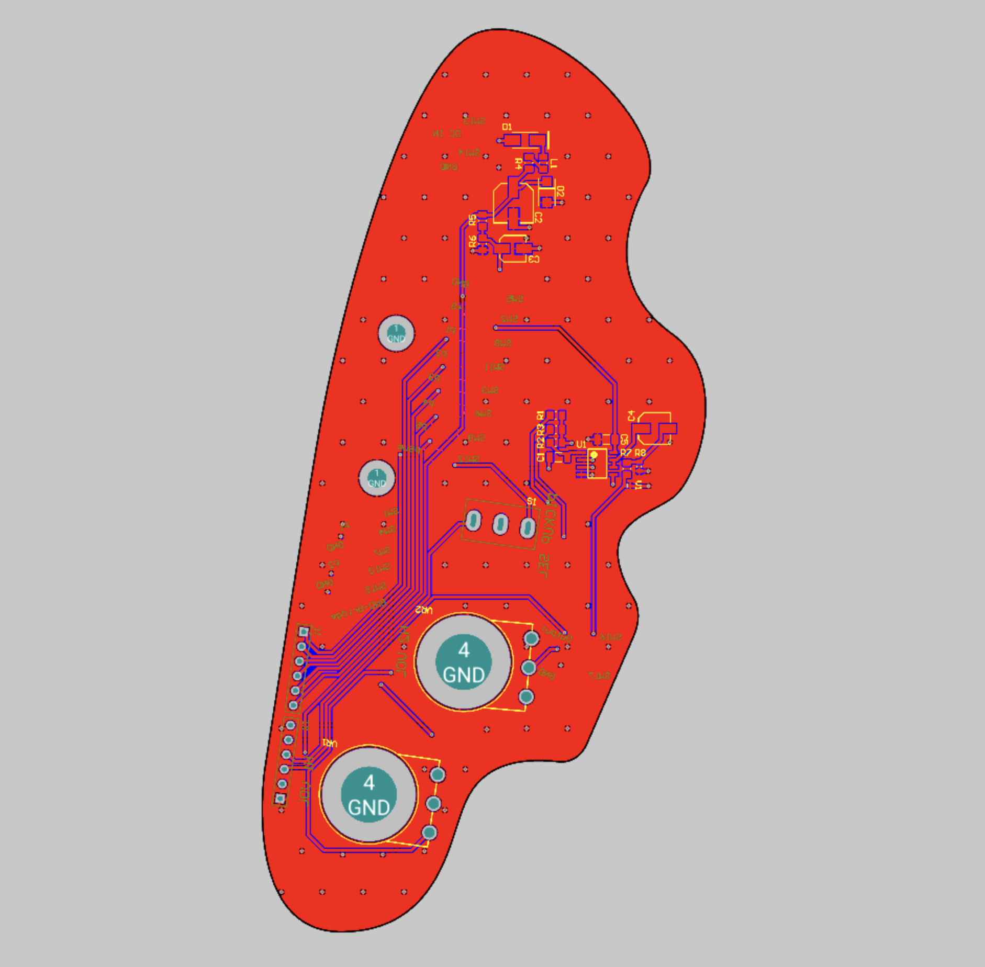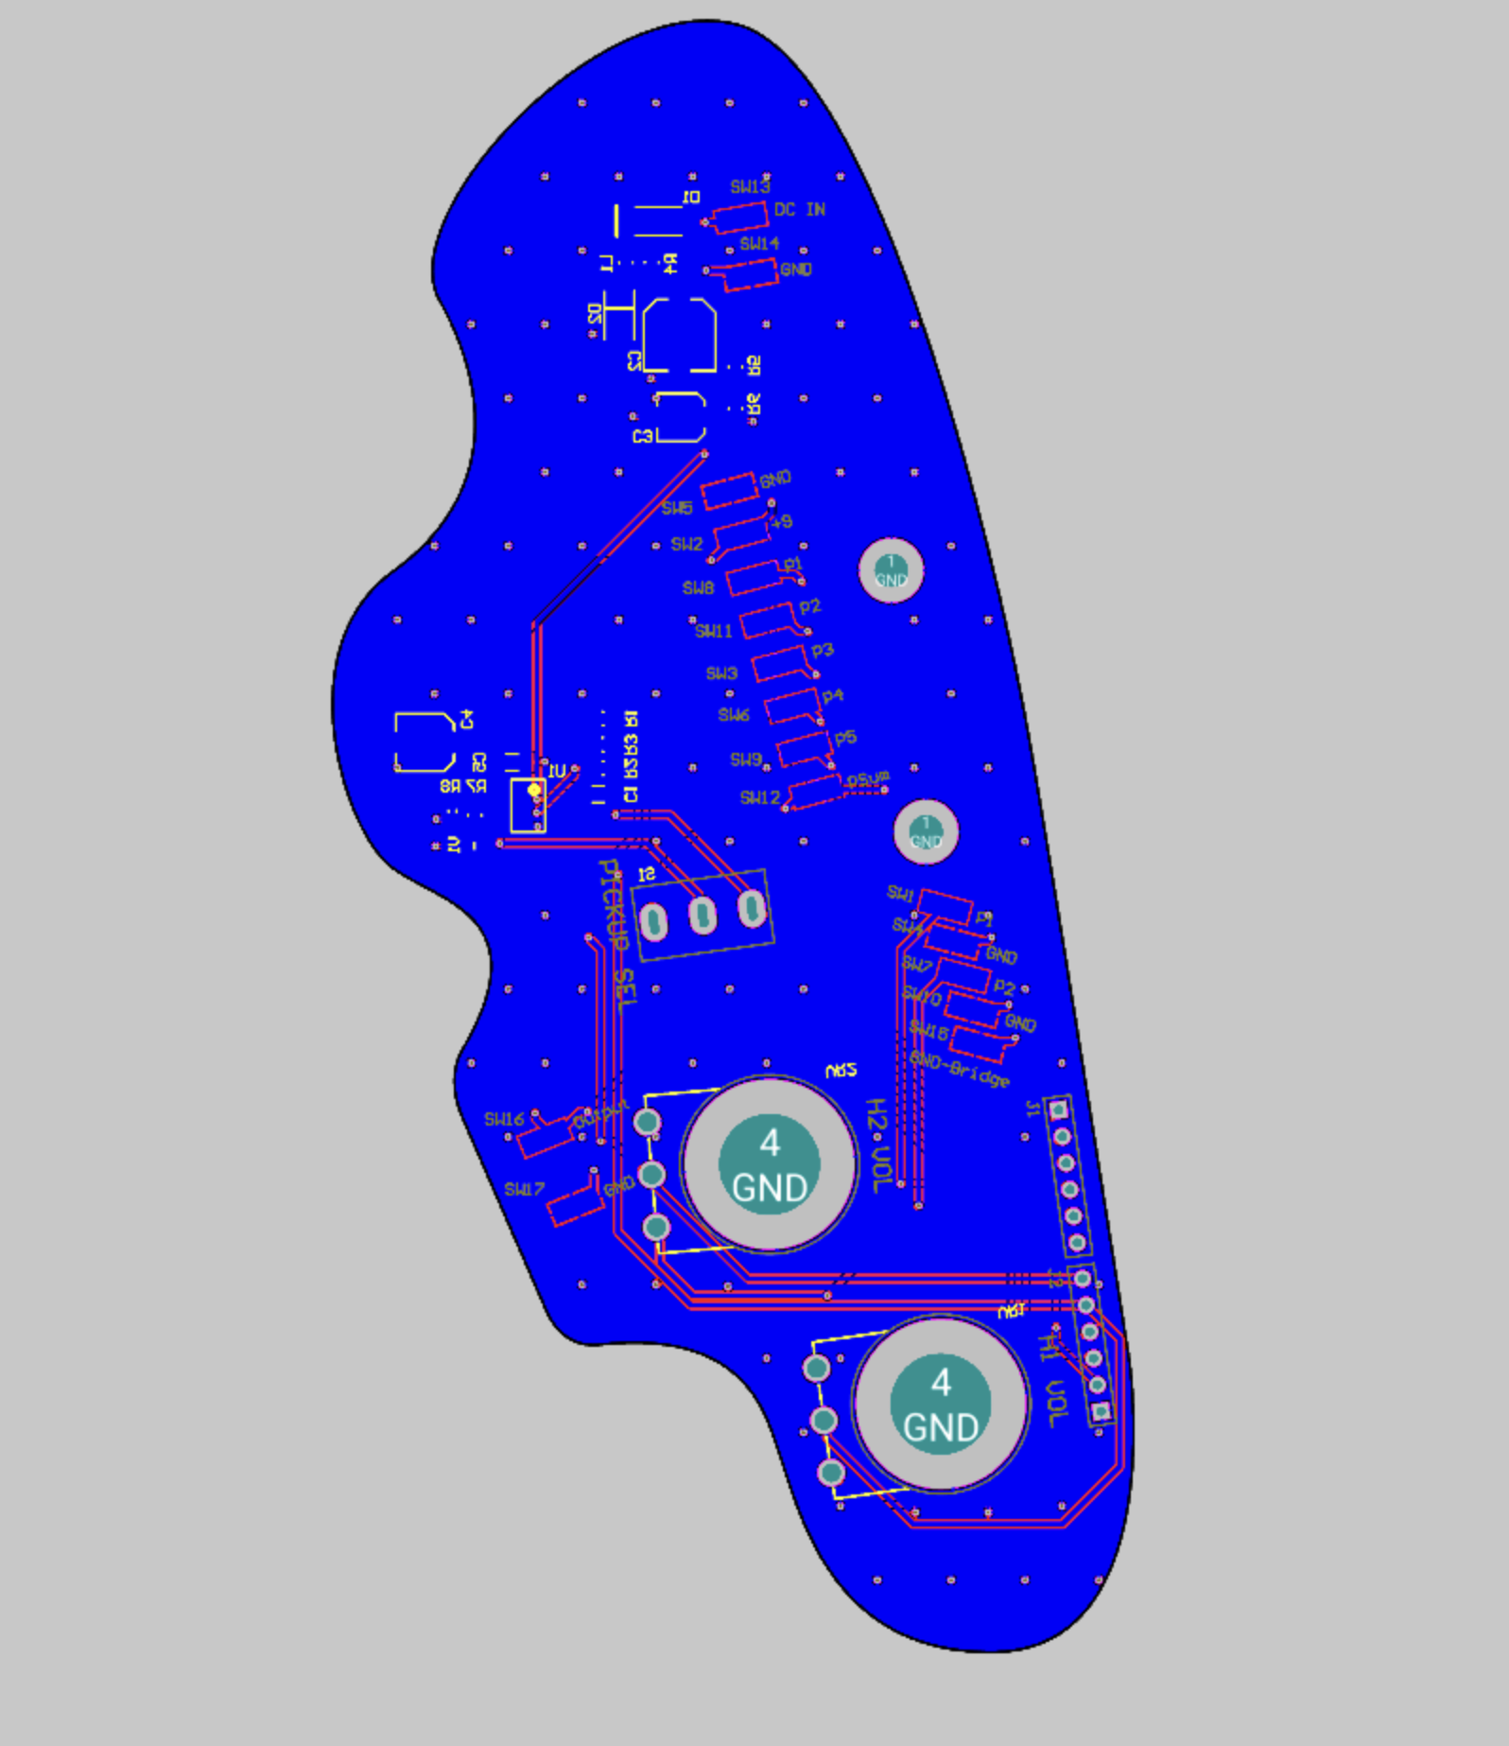

Figure 35. PCB Layout. Left: Top Layer. Right: Bottom Layer.

To hold all the cables and PCB in the cavity, a 3D printed panel was made. Figure 36 and Figure 37 below contain the fully assembled PCB and bass guitar.



Figure 36. Assembled PCB. Left: Bottom Layer. Right: Top Layer.

(To be Added)

Figure 37. Assembled Bass and 3D Printed Panel.

## Test Data and Considerations

The test data for the correlation process were audio clips recorded at 48 KHz sampling frequency using both pickups simultaneously. Using the audio recordings, the correlation data is gathered using the python script. The fundamental frequency of the clean and the processed signal are estimated using python, and the data is correlated. Three octaver versions were tested: the floating-point processing, integer processing, and a release version. Due to the synthesizer being in development, an early test candidate of the virtual instrument was tested. The main points of consideration from the correlation are as follows:

1. Tracking Stability.
2. Pitch Deviations.
3. Settling Time.
4. Error Conditions.
5. Spectral Data.

The tracking stability is defined as the overall ability of the algorithm to maintain the F0 estimates throughout the duration of the audio. The F0 estimates are made using python signal processing tool kit (PYSPTK). Good algorithm behavior indicates no pitch errors in the algorithm functionality. Furthermore, the pitch deviations may occur at the initial transient of the audio clip – these cases are ignored as various factors that are difficult to control may cause the deviation.

The settling time outlines the time the algorithm requires to return to a stable value in case a deviation occurs. Ideal behavior of the algorithm would result in instantaneous recovery. However, in practice, this may not be the case, therefore settling times of the less than 50 ms (milliseconds) are deemed satisfactory. Moreover, the setting time may not be required as a gauge for the pickups, therefore, it is not the primary factor of testing.

Although most error conditions are known and flagged, new errors may arise due to the nature of the pickups. The errors are categorized and used as the main factor for the pickup selection. Least number of errors produced by a specific pickup would be the straightforward choice.

Lastly, the spectral data of each pickup is analyzed to assess the harmonic content differences between the two pickup types. Spectral analysis of the pickups may provide a broader understanding over the errors and additional measures can be implemented or developed to overcome them. It is quite vital to note that the errors may not be directly perceivable by the end-user, but it may cause disruptions in other aspects of the algorithm and usage. Therefore, all errors cases are considered.

## Python Testing Script and Sonic Visualizer

Using python, the audio data from using the two pickups were correlated. The script intends to detect error cases and flag them appropriately. Furthermore, it provides a graphical representation of transient changes in the detection parameters. The data flow for testing is shown in Figure 38.

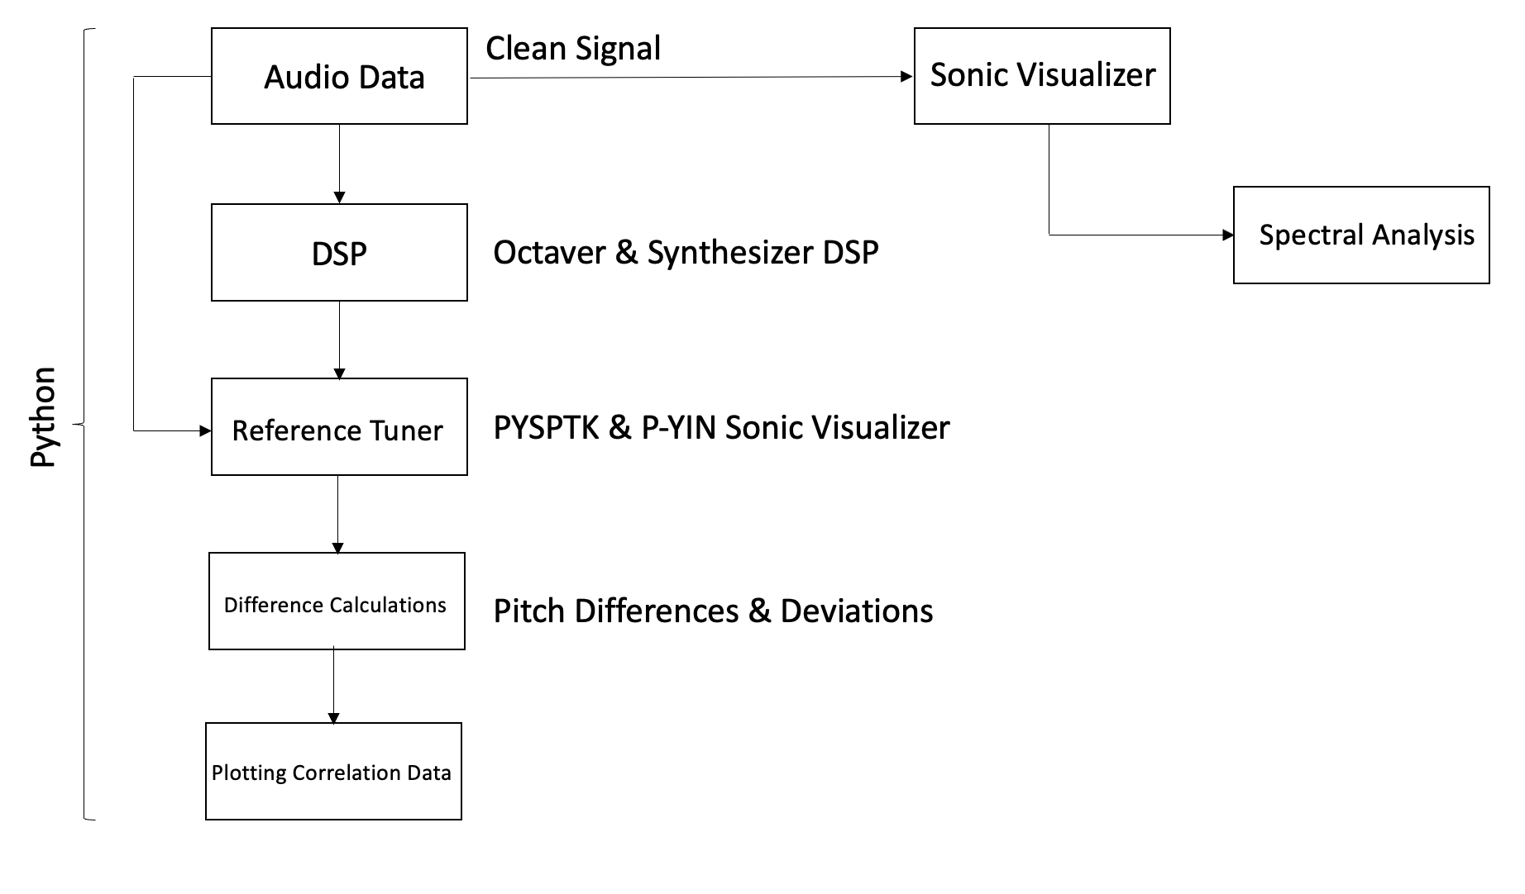Figure 38. Testing Data Flow.

The python testing script utilized various libraries – primary operations were carried out using Python Signal Processing Tool Kit (PYSPTK), Librosa, Matplot and Numpy libraries. Using object-oriented programming, the correlation tools were written in the class Analyzer (Appendix 2). A diverse set of tools were chosen since the generic tools inherently cause difficulties in interpreting the data.

The audio signal is loaded using Librosa. A sampling averaging function was implemented for large audio data for the correlation utilities. The averaging function calculates the average of the samples of window width $W$. Although this reduces the overall processing time, using large window sizes causes aliasing, thus disrupting the correlation. The averaging function was implemented as a redundancy step for preventing excessive processing time for development. Various optimization steps were implemented in other functions. Subsequently, the audio data is batch processed using the DSP for the octaver. The synthesizer uses a post-processed rendered sample. Listing 5 contains the averaging function code.

for i in range(0, len(data), self.window):

subsampled.append(np.mean(data[i:i+self.window]))

return np.array(subsampled), sr

Listing 5. Averaging Function.

The PYSPTK library’s SWIPE fundamental frequency (F0) estimation algorithm was the core tool employed. The function calculates the F0 estimate over a fixed window length with hop size $n$. Clean and processed signal’s F0 estimates generally showed an abundance of noise in the estimates at the silent segments of the signal. Furthermore, the estimates had large F0 jumps when a wide search range was utilized. To overcome this, the search range was limited from 10 Hz to 600 Hz, as the bass guitar’s highest note is at 523.25 Hz (C5). Similarly, a noise gate was implemented on the F0 data using the Librosa library. A value from the estimate is only accepted when the signal crosses a fixed threshold. Using binary masks, the unvoiced segments are rendered to null and multiplied with the F0 data array. The accuracy of the F0 estimates were also checked for errors using Sonic Visualizer’s P-YIN plugin. Listing 6 contains the binary mask calculation and noise gating of the F0 array.

if self.threshold is not None:

#Compute the non-silent intervals (i.e., the intervals where the signal is above a certain threshold)

non_silent_intervals = librosa.effects.split(data, top_db=self.threshold)

#Create a binary mask to nullify the silent parts

mask = np.zeros_like(data, dtype=bool)

for interval in non_silent_intervals:

start = interval[0]

end = interval[1]

mask[start:end] = True

#Applying the mask

f = f * mask

else: mask = None

Listing 6. Binary Mask Generation and Noise Gating.

The octaver models generate debugging data and the script implements functions to detect changes in square wave data. The main processing is implemented for the square waves generated from the set-reset cycle of the octave divider. Essentially, the fundamental frequency can also be estimated using this data because of the readily available wavelengths. Moreover, the F0 changes help detect octave and phase errors are easily viable from the correlation of the set-reset cycle. The data is processed using the function presented in Listing 7.

ctr = 0

f = []

store = 0

for j in range(1, len(data)):

if (data[j] * data[j-1] < 0):

if ctr > 1:

store = (fs/ctr)/2

else:

store = 0

ctr = 0

else:

ctr += 1

f.append(store)

f.append(f[len(f)-1])

Listing 7. Set-Reset Cycle Frequency Estimation.

The processed is performed by calculating the product of the sample at index j and the preceding sample at j-1. When the product returns a negative value, it denotes a change in the polarity of the square wave. Subsequently, the value is stored, and the frequency is calculated only when the number of samples counted exceeds 1; the estimation is performed by dividing the sampling frequency against the number of samples counted before the sign change.

The final function performs the main correlation by calculating the deviation in F0 estimates with respect to the clean signal. Flags for excessive deviation and octave errors are also set. The pitch differences between the clean and processed signal are calculated using Equation (13). Tolerance for differences is set between 5% and 10% bounds. The flags raise a value of 1 (HIGH) when a discrepancy beyond the bounds is detected, otherwise sets a 0 (LOW). In certain cases, a value of -1 is set for ignoring the values. Below Listing 8 shows the flagging mechanism. The last value of each flag array is set to LOW or Ignore.

setFlag = []

isOctave = []

tol = self.tolerance / 10

for i in range(0, len(semi)-1):

if semi[i] == float('nan'):

setFlag.append(-1)

elif semi[i] == 0:

setFlag.append(0)

elif semi[i+1] - semi[i] != semi[i]:

if semi[i] >= semi[i+1] * (1 - tol) and semi[i] <= semi[i+1] * (1 + tol):

setFlag.append(1)

else:

setFlag.append(0)

if (1 - tol) * 12 <= semi[i] <= (1 + tol) * 12 or semi[i] > 12:

isOctave.append(1)

else:

isOctave.append(0)

setFlag.append(-1) #Ignoring last value

isOctave.append(0) #Ignoring last value

Listing 8. Flagging Mechanism.

The data from the correlation functions are plotted against time along with the clean and processed signal using the Matplot library. The function Plot (Appendix 2) implements a method for plotting certain correlation values at a time, to improve the ease of analysis. Furthermore, the data values are scaled such that information does not overlap. Legends were also implemented to enhance visibility. Figure 39 shows a sample plotting function output.



Figure 39. Sample Plotting Function Output.

Spectral analysis of the pickups was performed using Sonic Visualizer’s spectrogram generator. The clean signal was utilized for the analysis. As pickups produce varying harmonic contents, the expected result is a difference in the contents of the harmonics. The spectrogram view of Sonic Visualizer is presented in Figure 40.

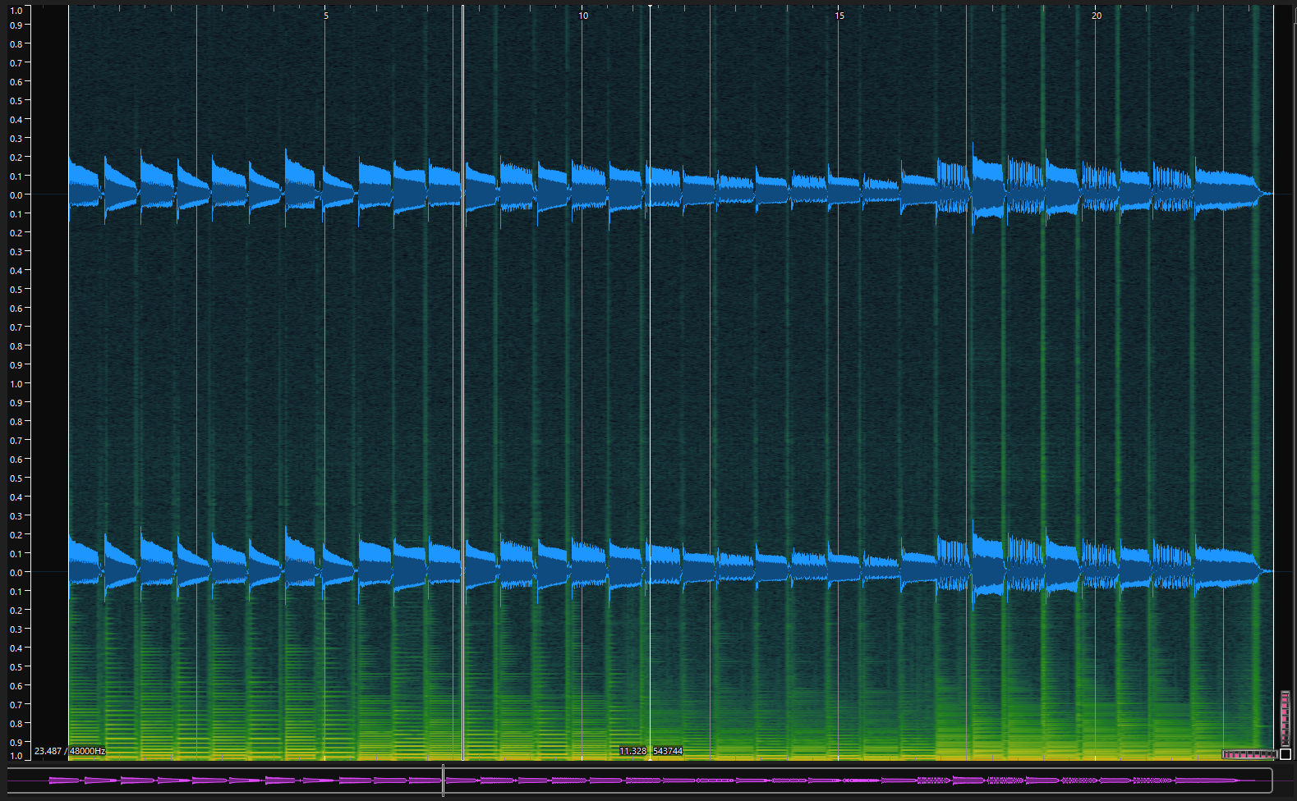

Figure 40. Spectrogram View using Sonic Visualizer.

# Results

## Data Correlation

## Error Cases and Types

## Pickup Types and Effects

# Discussion

# Conclusion

References

* 1. <https://en.wikipedia.org/wiki/Timbre#:~:text=In%20music%2C%20timbre%20(%2F%CB%88,choir%20voices%20and%20musical%20instruments>.
  2. <https://www.analog.com/en/design-center/landing-pages/001/beginners-guide-to-dsp.html>
  3. <https://www.analog.com/en/design-center/glossary/sampling-rate.html>
  4. <http://musicweb.ucsd.edu/~trsmyth/digitalAudio171/Nyquist_Sampling_Theorem.html>
  5. <https://towardsdatascience.com/all-you-need-to-know-to-start-speech-processing-with-deep-learning-102c916edf62#:~:text=Window%20length%20is%20the%20length,portion%20of%20the%20window%20length>. Harsh Maheshwari
  6. <https://dsp.stackexchange.com/questions/40784/what-is-the-relation-between-windowing-and-hopping-in-audio-dsp> Laurent Duval
  7. <https://towardsdatascience.com/understanding-audio-data-fourier-transform-fft-spectrogram-and-speech-recognition-a4072d228520> Karthik Chaudary
  8. <http://hyperphysics.phy-astr.gsu.edu/hbase/Waves/funhar.html>
  9. <https://learncigarboxguitar.com/content/standing-waves-and-harmonic-series>
  10. <https://www.physik.uzh.ch/local/teaching/SPI301/LV-2015-Help/lvanlsconcepts.chm/Spectral_Leakage.html#:~:text=In%20spectral%20leakage%2C%20the%20energy,exactly%20repeats%20throughout%20all%20time>.
  11. <https://www.tutorialspoint.com/autocorrelation-function-and-its-properties> Manish Kumar Saini
  12. <https://pages.mtu.edu/~suits/autocorrelation.html>
  13. YIN Alain de Cheveigné and Hideki Kawahara
  14. <https://en.wikipedia.org/wiki/Semitone>
  15. <https://www.cycfi.com/2013/11/sustain-myth-science/>
  16. <https://astronomy.swin.edu.au/cosmos/d/Destructive+Interference#:~:text=Destructive%20interference%20occurs%20when%20the,the%20resulting%20wave%20is%20zero>.
  17. <https://en.wikipedia.org/wiki/Sound_hole>
  18. <https://en.wikipedia.org/wiki/Pickup_(music_technology)>
  19. <http://www.till.com/articles/PickupResponse/index.html> J Donald Tillman
  20. <https://www.yamaha.com/en/musical_instrument_guide/electric_guitar/mechanism/mechanism002.html>
  21. <http://hyperphysics.phy-astr.gsu.edu/hbase/electric/farlaw.html>
  22. <http://buildyourguitar.com/resources/lemme/>
  23. Experimental Study of a Guitar Pickup P Lotton, B Lihoreau, E Brasseur.
  24. Douglas Self Small Signal Audio
  25. <https://www.fender.com/articles/instruments/electric-guitar-pickup-types-how-to-choose-your-pickup#:~:text=Single%2Dcoil%20pickups%20have%20been,while%20you%20are%20not%20playing>.
  26. [https://www.seymourduncan.com/blog/latest-updates/the-anatomy-of-single-coil-pickups](https://www.seymourduncan.com/blog/latest-updates/the-anatomy-of-single-coil-pickups )
  27. <https://48chicagoblues.com/EMG%20H1A/EMG%20details.htm>
  28. <https://www.explainthatstuff.com/piezoelectricity.html>
  29. <https://www.esptakamine.com/articles/2013621-inside-the-takamine-palathetic-pickup>
  30. <https://www.seymourduncan.com/blog/latest-updates/piezo-vs-magnetic-pickups>
  31. <https://sound-au.com/project202.htm>
  32. <https://resources.pcb.cadence.com/blog/2022-how-to-stop-radio-frequency-interference>
  33. <https://www.electronics-tutorials.ws/resistor/varistor.html>

Use one of the referencing systems below. Remove the one that you do not use.

Harvard (author-date) system:

The reference list entries need to be in alphabetical order according to the last name of the author mentioned first in the list of authors.

Davies, Barbara; Jameson, Peter & Smith, John. 2013. Advanced economics. Oxford: Oxford University Press.

Mitchell, John Arnold & Thomson, Magdalena. 2017. A guide to citation. London: London Publishings.

Vancouver (numbering) system:

1. Mitchell, John Arnold & Thomson, Magdalena. 2017. A guide to citation. London: London Publishings.
2. Davies, Barbara; Jameson, Peter & Smith, John. 2013. Advanced economics. Oxford: Oxford University Press.

Datasheets





The appendices are not inserted into the table of contents automatically. Instead,

Source Code

